**Startup Launchpad for Young Female Entrepreneurs – Comprehensive Training Report**

**Overview**

**Introduction**

The *SproutBud Startup Launchpad for Young Female Entrepreneurs* is an intensive training and mentorship program designed to empower young women in Nigeria. It equips them with critical business skills, financial literacy, digital tools, and mentorship to launch, scale, and sustain successful businesses. This initiative aligns with our mission to foster economic inclusion, bridge the gender gap in entrepreneurship, and create a supportive ecosystem for women-led businesses.

**Program Objectives**

* To provide young women with essential business skills and financial literacy.
* To create a community and support network for young female entrepreneurs.
* To enhance digital readiness and leverage technology for business growth.
* To bridge the gap in financial inclusion by equipping women with tools for sustainable business development.

**Program Overview**

Ten participants were selected for the program. The training spanned six weeks, covering the following modules:

| **Week** | **Modules Covered** | **Facilitators** |
| --- | --- | --- |
| 1 | Onboarding, Orientation, and Q&A | SproutBud Team (Led by Imomoemi Yougha) |
| 2 | Business Foundations, Digital Readiness, Business Ideation, Structuring, Market Research, Digital Tools | Adejoke Dako |
| 3 | Financial Literacy, Branding, Sales Strategies | Ene Ogwuche & Bayode John |
| 4 | Business Operations, Legal Compliance, Technology in Business | Elizabeth Christopher & Itoro Eghenayamu |
| 5 | Leadership, Networking, and Business Growth Strategies | Etimbuk Ikpeme & Imomoemi Yougha |
| 6 | Practical Sessions, Business Acceleration, Close-Out Ceremony, Certification | Oluwatosin Christopher |

**Program Highlights**

* Week 1: Orientation introduced participants to the program's goals and community-building aspects.
* Week 2: Focused on business foundations and digital readiness. Key sessions covered market research and digital tools.
* Week 3: Covered financial literacy, brand identity, customer engagement, and sales strategies.
* Week 4: Emphasized business operations, legal compliance, and the role of technology in sustainable growth.
* Week 5: Built leadership skills, networking confidence, and business scaling strategies.
* Week 6: Featured practical applications, business pitch sessions, and final certification. Five participants were selected for mentorship based on successful participation and completion.

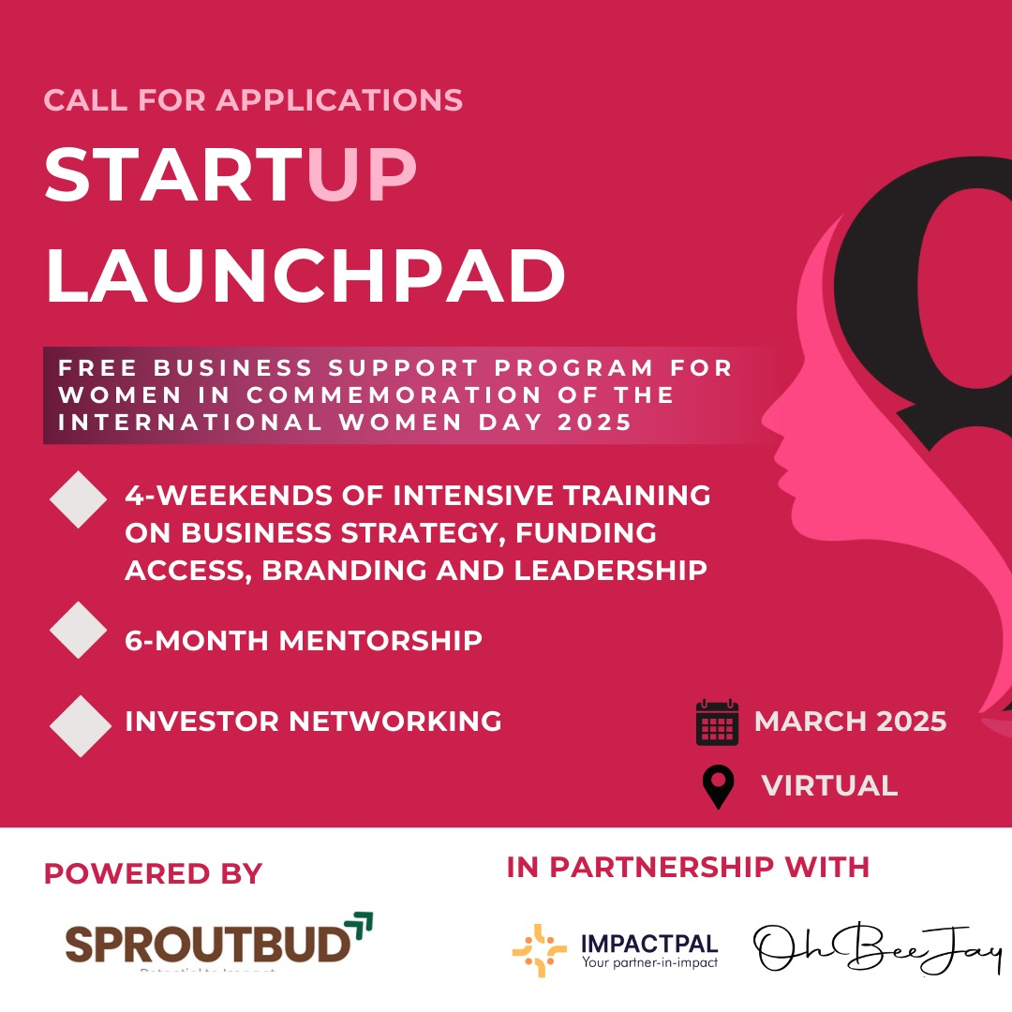

**Program Highlights**

Week 1: Onboarding, Orientation and Q & A. By SproutBud Team led by Imomoemi Yougha

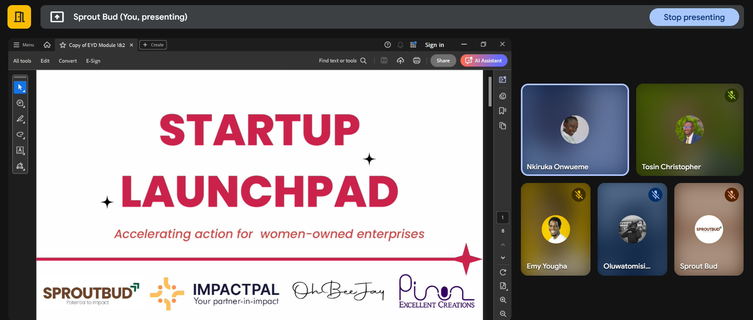

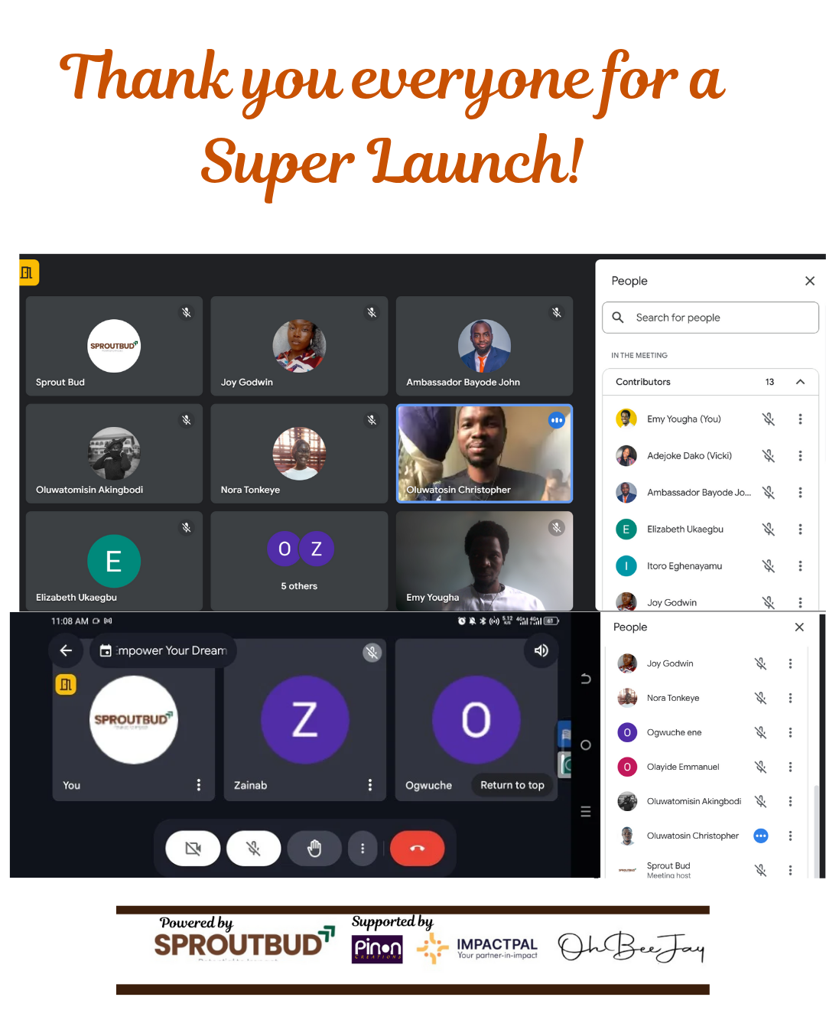

Week 2: Focused on Business Foundations and Digital Readiness, featuring impactful sessions on business ideation, structuring, market research, and digital tools. By Adejoke Dako

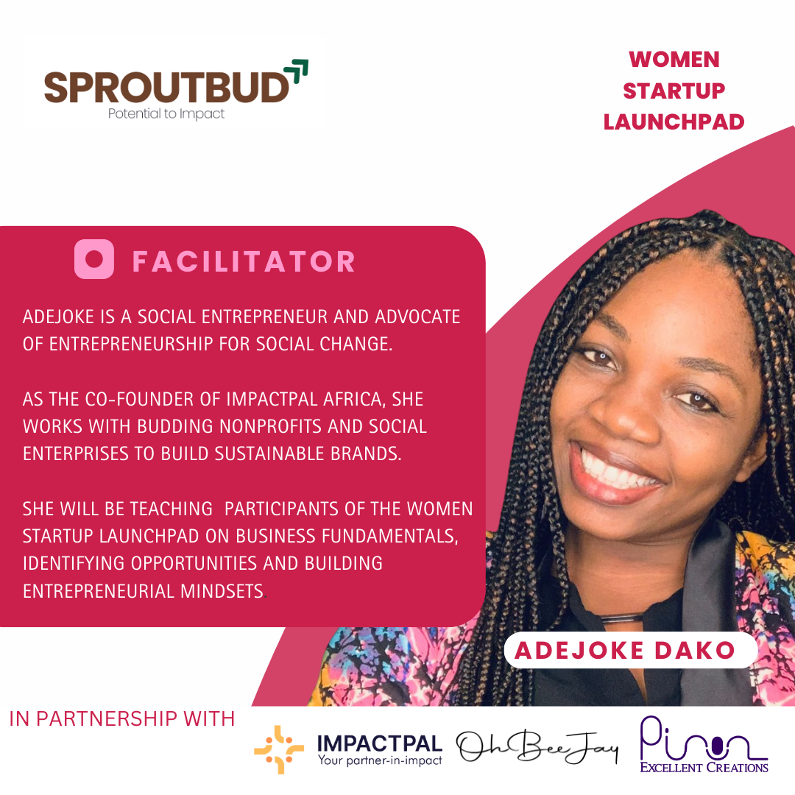

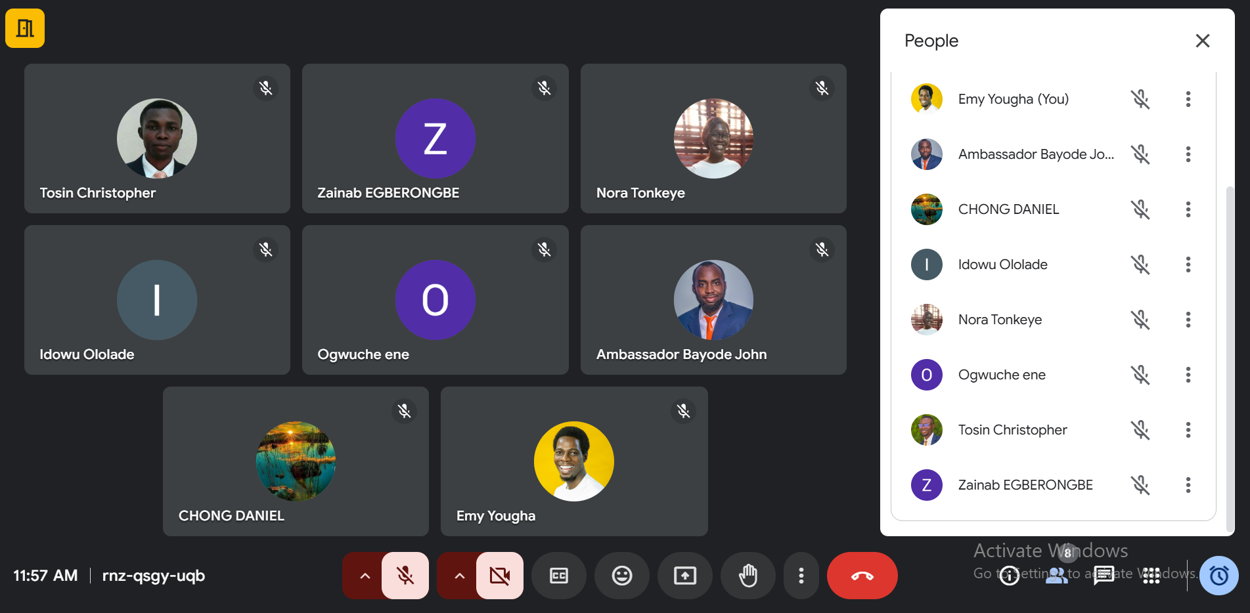

Week 3: Covered Financial Literacy, Branding, and Sales Strategies, emphasizing financial management, brand identity, and customer engagement. By Ene Ogwuche and Bayode John

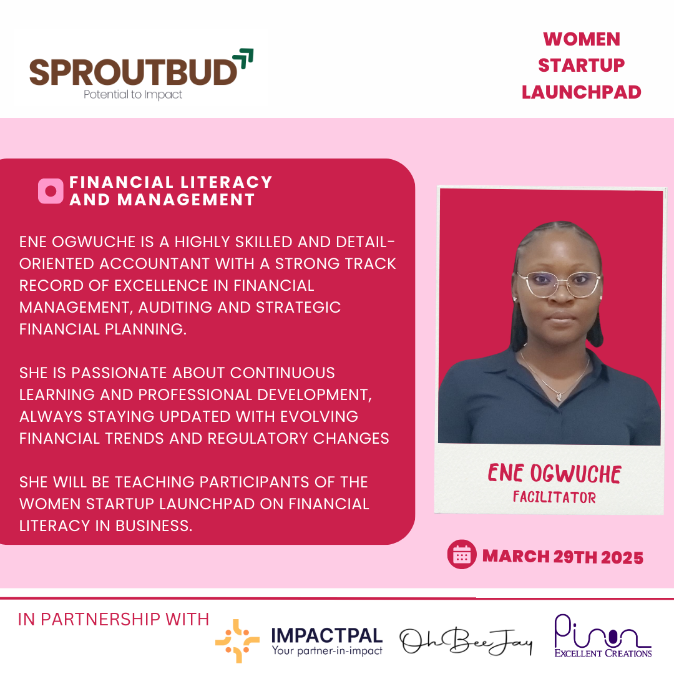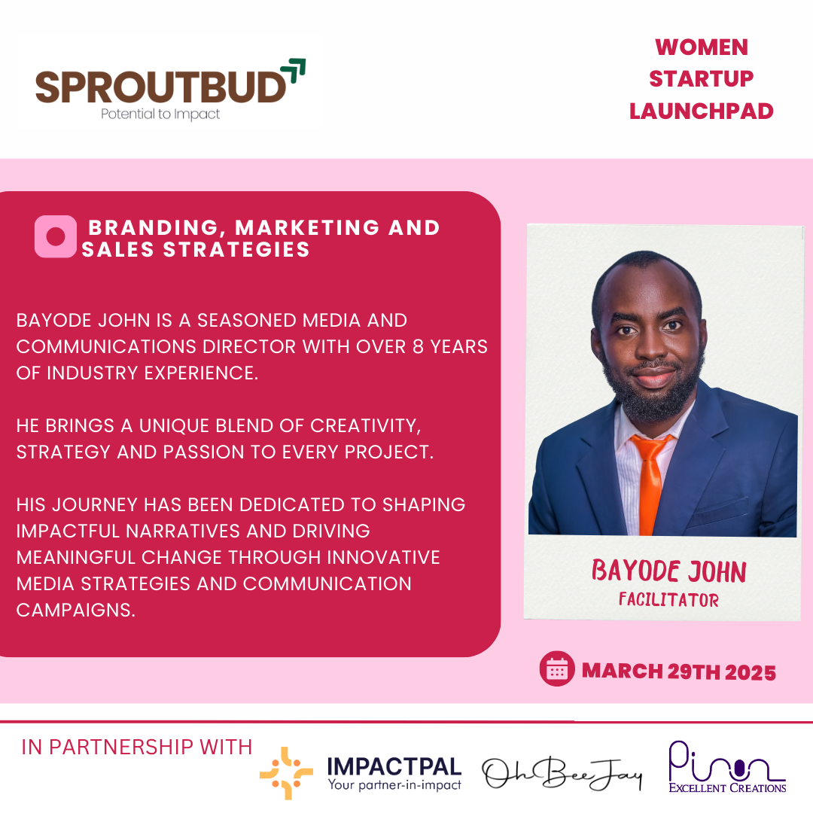



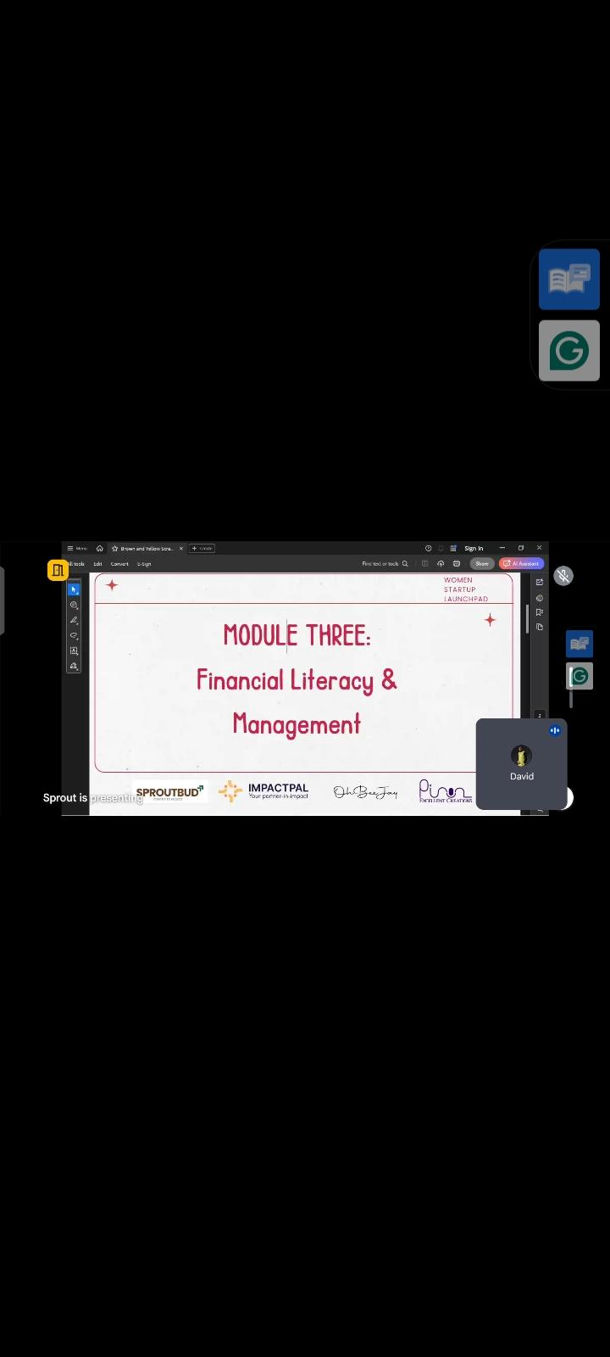

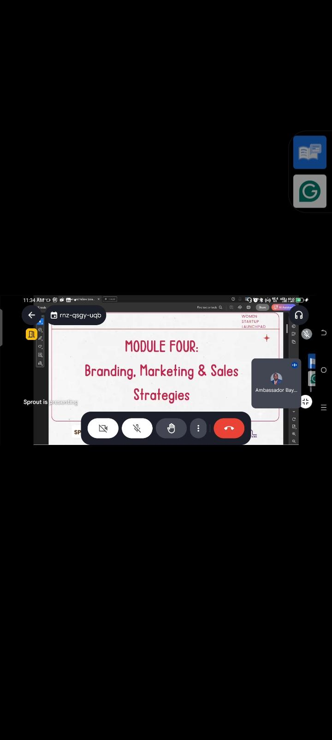

Week 4: Addressed Business Operations, Legal Compliance, and Technology, preparing participants for sustainable growth and operational excellence.

By Elizabeth Christopher and Itoro Eghenayamu

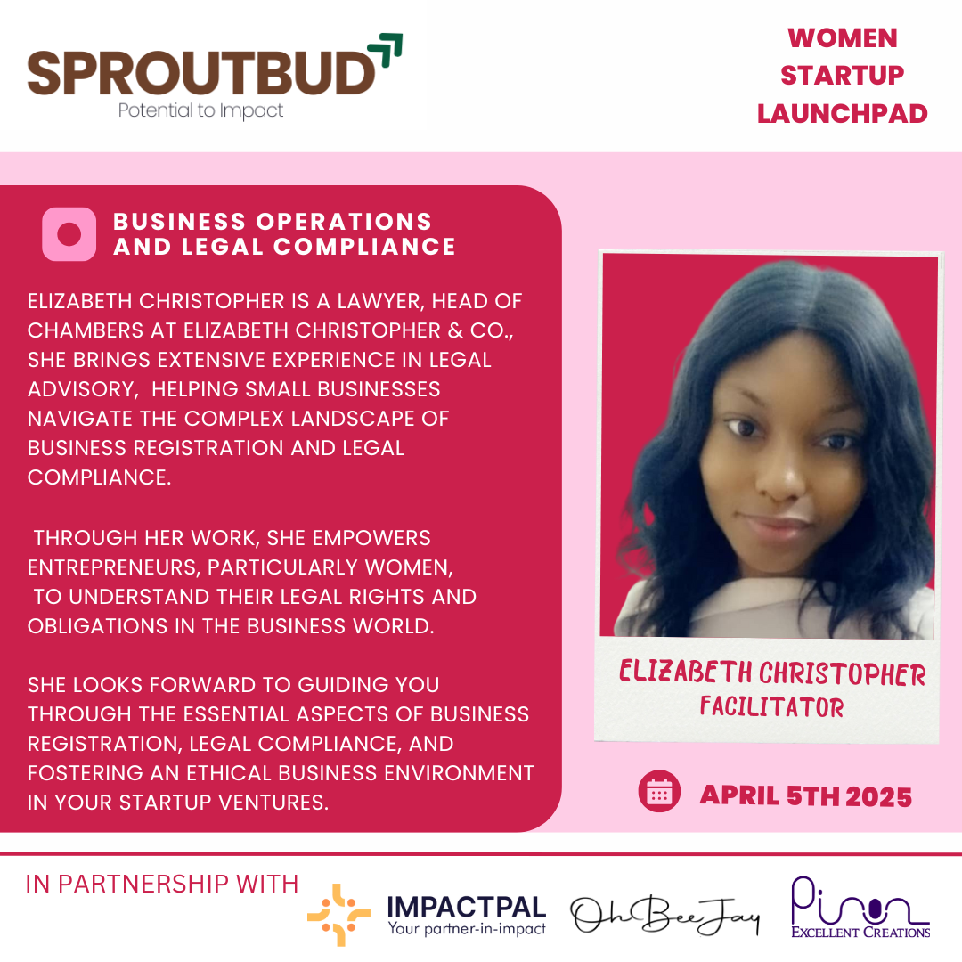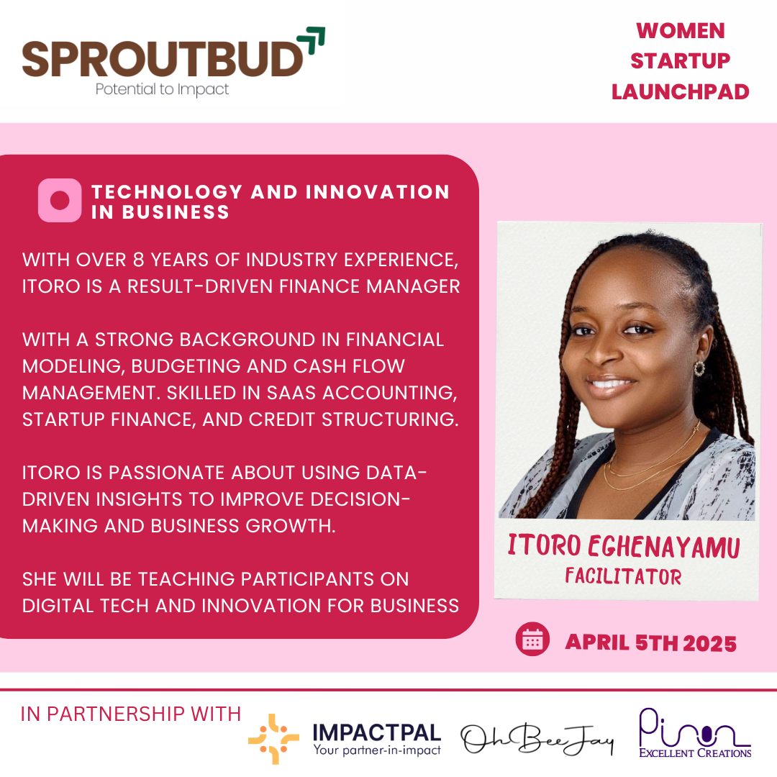

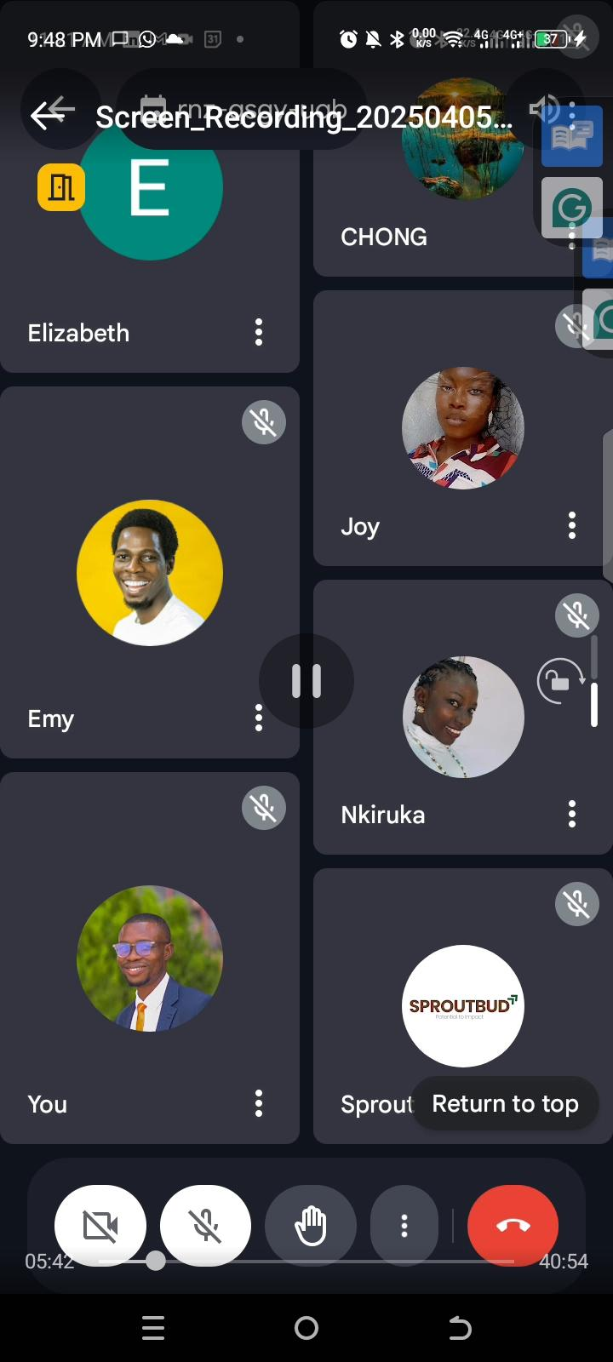

5: Concluded with Leadership, Networking, and Growth, providing participants with essential leadership skills, networking techniques, and business growth strategies. By Etimbuk Ikpeme and Imomoemi

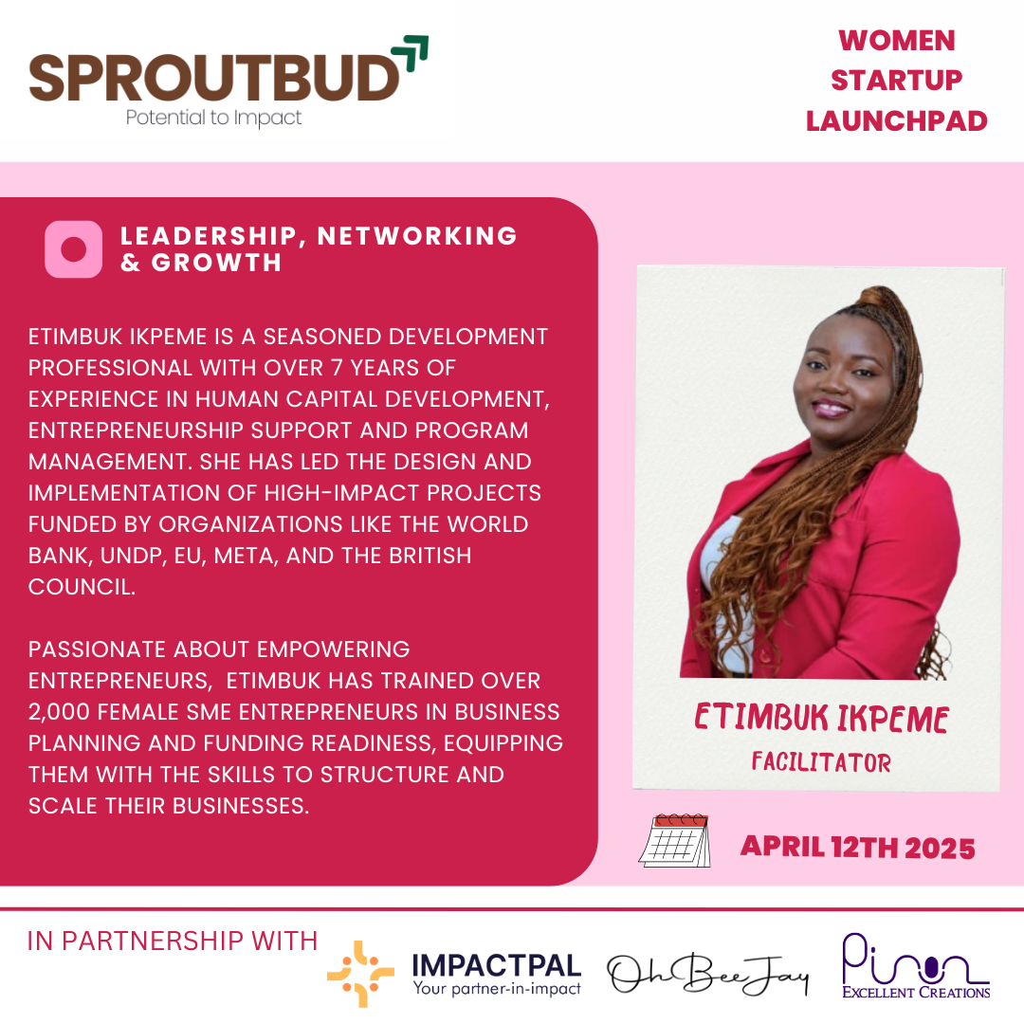

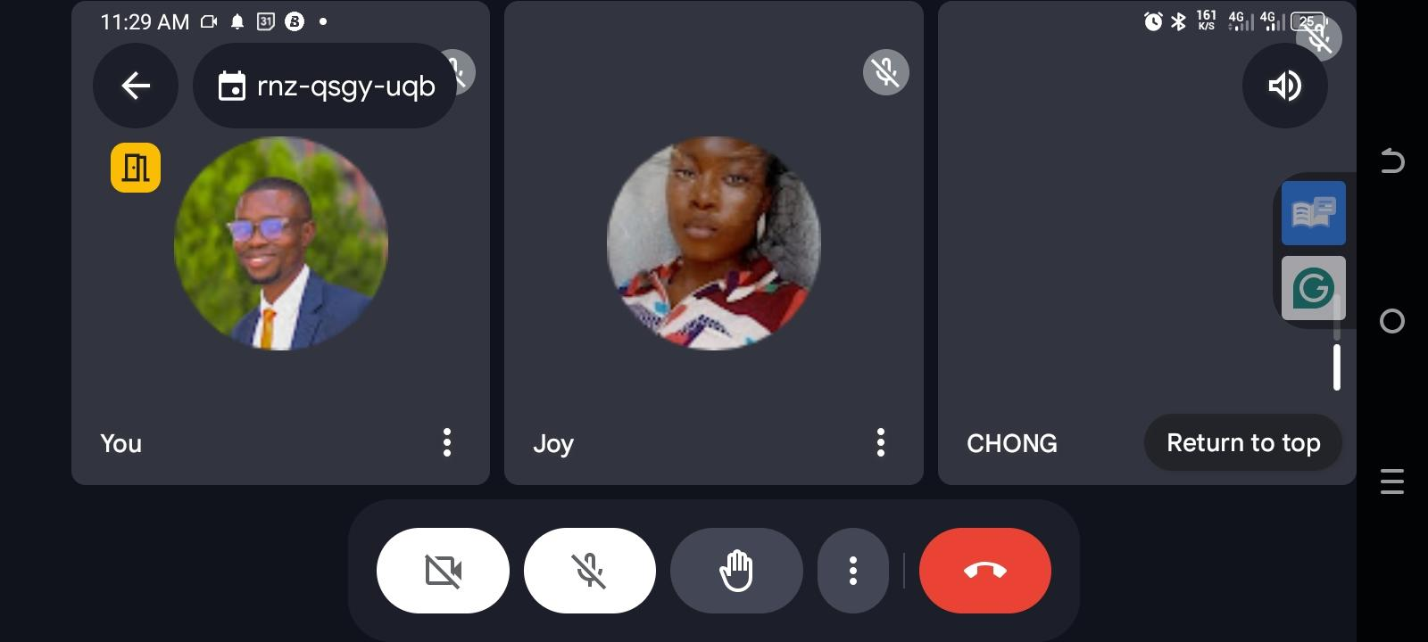

**Week 6: Practical Sessions & Business Acceleration, Training** Close out ceremony and Certification. Selection of successful participants for Mentorship - 5 Business were selected based on successfully participation and completion of the training. Plans provided to remaining women entrepreneurs to complete training and proceed to mentorship - Led by Oluwatosin Christopher 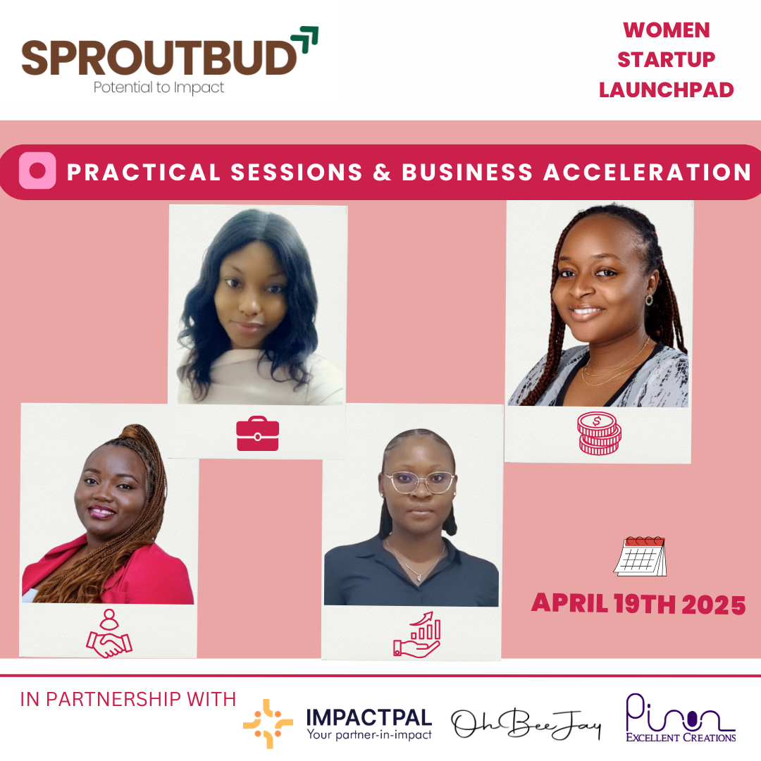

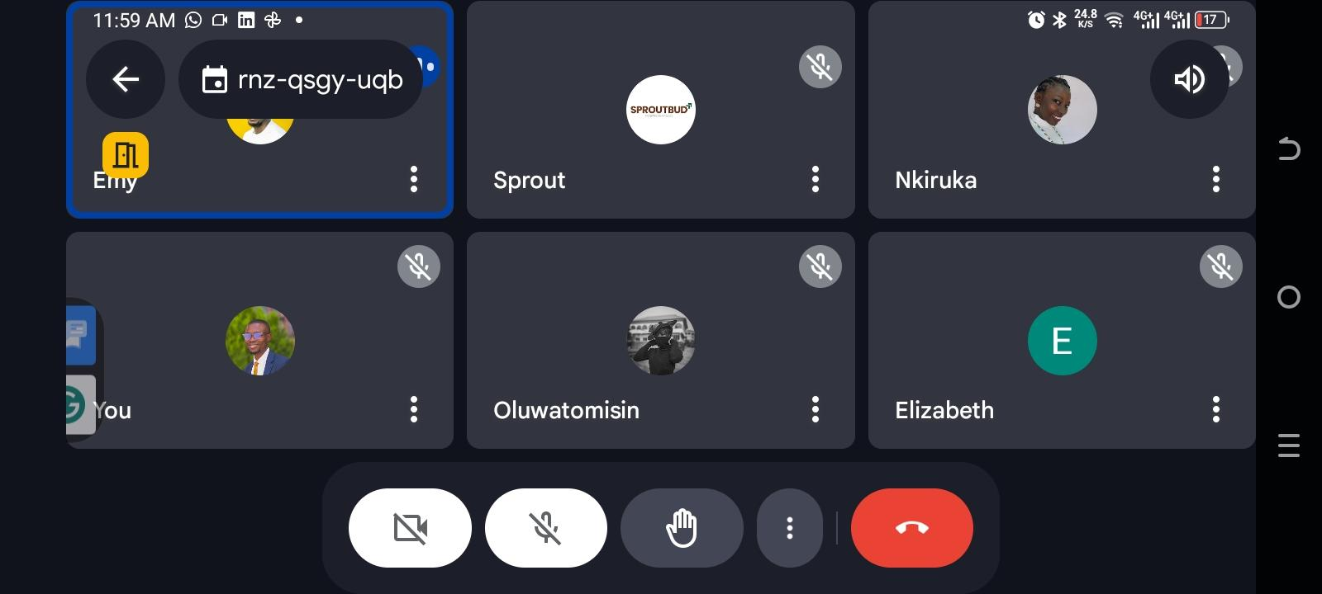

**Impact and Outcomes**

* Full engagement from 10 participants, reflecting high interest and commitment.
* Development of individual business plans, digital strategies, and growth roadmaps.
* Marked improvement in financial literacy and digital competencies.
* Increased confidence in pitching, public speaking, and networking.

**Participant Feedback**

"This program gave me the tools to finally launch my dream business. The mentorship and digital training were invaluable." — *Sarah, participant*

"I feel more confident in managing my business finances and presenting my ideas to investors." — *Aisha, participant*

**Facilitators and Mentorship**

We were honored to host accomplished industry experts, including:

* **Adejoke Dako** – Co-founder of ImpactPal
* **Ene Ogwuche** – Financial Coach and Strategist
* **Bayode John** – Branding and Sales Expert
* **Elizabeth Christopher** – Legal Compliance Consultant
* **Itoro Eghenayamu** – Technology and Business Strategist
* **Etimbuk Ikpeme**  – Leadership and Business Development Coach
* **Imomoemi Yougha** – Head of Partnership & Strategy
* **Oluwatosin Christopher** - Head of Program, SproutBud

These seasoned professionals provided mentorship, guidance, and practical insights to participants throughout the program.

**Challenges and Lessons Learned**

* Managing internet/data costs for participants in remote areas.
* Balancing training intensity with participants' availability and other responsibilities.
* Identifying the need for continued support post-training.

Needs for continuous support post-training.

**Next Steps**

* Launch of a six-month mentorship phase to provide personalized guidance.
* Regular check-ins and impact assessments to track participants' business progress.
* Expansion of the program to reach more women across Nigeria and other regions.

**Conclusion**

The *Startup Launchpad for Young Female Entrepreneurs* has successfully laid the foundation for a new wave of empowered, well-equipped women entrepreneurs. We are proud of the significant progress achieved and are committed to providing ongoing support as these entrepreneurs build and grow their ventures.

**Acknowledgments**

We extend heartfelt thanks to our partners, facilitators, mentors, and supporters. Your contributions have made this program a success and a meaningful step toward economic empowerment for women.

*Prepared by the SproutBud Team*